Led State Machine Module Design

History
Issue status  (Index) | Maturity/Date  (draft/invalid/valid)  (dd-mmm-yyyy) | Author  Department | Check/Release  Department | Description
1.0 | Draft  06-Aug-15 | Roberto Palos | Alexis Garcia / Roberto Palos | Creation of the document
1.1 | Draft  06-Aug-15 | Alexis Garcia | Alexis Garcia / Roberto Palos | Correction of the redaction , and addition of some parts

Table of Contents
1 Purpose 3
2 Definitions and abbreviations 3
3 Realization constraints and targets 3
4 SW Conceptual design 3
5 SW Component internal breakdown 4

Purpose
This Document has been created to detail the functionality for the led state machine in the project LIN Slave 4.

Definitions and abbreviations
Definitions
LIN  Master  Slave | Protocol of Communication (local interconnect network).  The node who controls the LIN network.  The node who response the petitions of the master in the LIN network.
HAL | Hardware Abstraction Layer.
MAL | Microcontroller Abstraction Layer.
APP | Application Layer.

Abbreviations
References
N° | Document name | Reference
1 | Traceability Matrix LIN Slave 4 | Traceability Matrix LIN Slave 4
2 | LIN Module Requirements | LIN Module Requirements

Realization constraints and targets

This module contains the control functionality for the led indicator in the LIN slave 4, this includes a state machine to control the status of the led , the led on, the led off and led toggling, also includes the configuration on the led.

SW Conceptual design
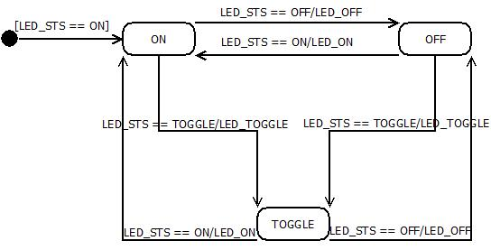
Figure 1 General State Diagram For Led State Machine.

ON: In this state the led must be on all the time.
OFF: In this state the led must be off all the time.
TOGGLE: In this state the led change his state every determinate time, switching from off to on or vice versa.

SW Component internal breakdown

Functional Decomposition

Function Description and Dynamic Behavior

Function <Type> <function name> (type par 1, .., type par n)

Description | Brief description of the function behavior and useful remarks
Parameter 1  <input| output| inout> | Give an explanation if the parameter shall be checked by the user, or if a check is implemented in the function here
Parameter 2..n
Return Value
Precondition | e.g. Function can only be called in a certain state, SW component is initialized  Relation between input parameters where applicable (Input for Module Test)
Post condition | e.g. specific State change e.g. car is locked, EEPROM Values written,  Relation between output parameters where applicable
Error Conditions

Dynamic Behavior

Function <Type> <function name> (type par 1, .., type par n)
Description | Brief description of the function behavior and useful remarks
Parameter 1
<input| output| inout>
Parameter 2..n
Return Value
Precondition | e.g. Function can only be called in a certain state, SW component is initialized  Relation between input parameters where applicable (Input for Module Test)
Post condition | e.g. specific State change e.g. car is locked, EEPROM Values written,  Relation between output parameters where applicable
Error Conditions

Dynamic Behavior

Macros

SW module global variables

Name | Type | Memory section | Description | Shared
LedStatus | T_UBYTE | RAM | Contains the value of led actual status , on off, and toggle | X

Design solutions for general features

SW Component integration

Integration context / constraints

Include files
GPIO.h, typedefs.h

Initialization
All function bellow shall be called on initialization
Call Order | Service | Call constraints linked to an other module

Interrupts

Real time scheduler task

Other entry points
Name | Service | Task level

